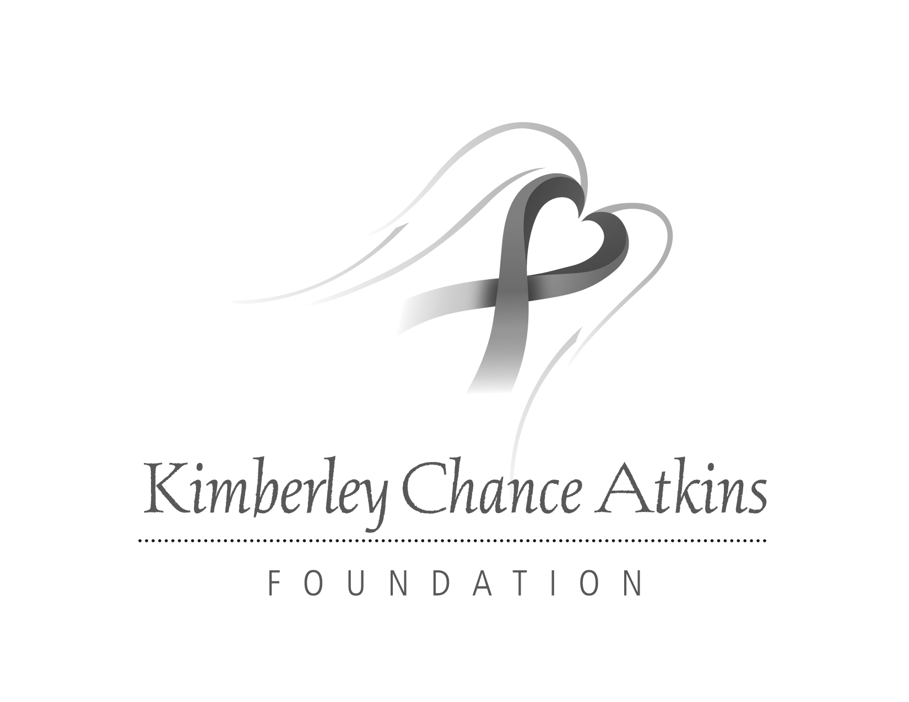
Wall of Hope Nomination Form
Nominate yourself, a friend or loved one that has beaten breast cancer for recognition on the Wall of Hope display in the Women’s Diagnostic Center at Rockdale Medical Center. The Wall of Hope features portraits of breast cancer survivors to inspire and provide hope for women facing uncertain and daunting diagnoses.
Women nominated for the Wall of Hope must meet the following criteria:
- Be a resident of Rockdale County;
- Be a breast cancer survivor;
- Be an example of strength and hope to friends and supporters.
Complete the form below and return it to: Kimberley Chance Atkins Foundation, Wall of Hope Nominations, Attention: Brenda Edwards, P.O. Box 1289, Conyers, GA 30012.
………………………………………………………………………………………………………
Name of Survivor: _____________________________________________________________
Address: _____________________________________________________________________
Phone Number: _______________________________________________________________
Number of years cancer free: _________________
Person nominating Survivor: ____________________________________________________
Address:______________________________________________________________________
Phone Number: ________________________________________________________________
How has the person you’re nominating been an example of hope and strength to friends and supporters? ____________________________________________________________________________________________________________________________________________________________________________________________________________________________________________________________________________________________________________________________________________________________________________________________________________________________________________________________________________________
Thank you for your nomination. Those selected to participate in the Wall of Hope will be notified by September 28.

